**A guide to getting roof bars for a roof tent**

**Summary**

Everything you need to know about getting roof bars for your car, in order to install a roof tent.

* Car roof types
* What roof bars should you get
* Where can you buy them
* Installing roof bars
* How does a roof tent attach to roof bars

**How roof bars work**

You can get roof bars for almost any vehicle, even if there are no obvious fixing points or raised side rails.

Roof bars run across your vehicle from side to side and they generally come in pairs. For a roof tent, you will need two roof bars.

The way they attach to your vehicle depends on your roof type. Your vehicle will have one of the following roof types.

**Open Rails**

Very obvious raised rails along the length of your car roof. They're "open" rails if there is a gap between the rail and your roof.

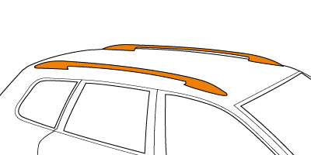

**Closed Rails**

A different type of raised rails that run along the length of your car roof. They're "closed" rails if there is **no** gap between the rail and your roof. These are also often referred to as "flush" rails.

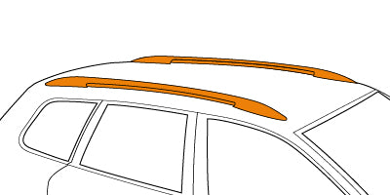

**Plain Roof**

No obvious fixing points. The bars clamp to the frame of your car, sometimes slotting into small holes under your door.

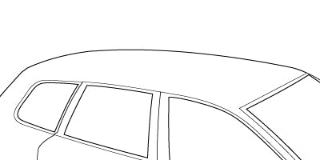

**Fixed Points**

Clear fixing points, often hidden behind a plastic covering in a channel that runs along the length of your roof. The bars will attach to these directly.

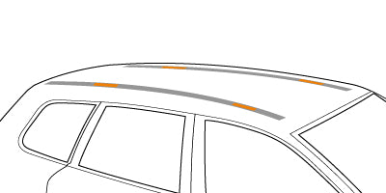

**Guttered**

A gutter system that runs along the top of your roof. Not very common, these are often featured on old school Land Rovers and similar style vehicles. The bars will clamp onto the gutter.

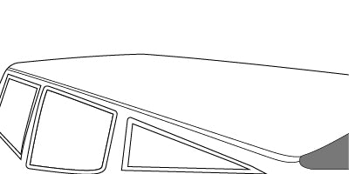

**Need help understanding roof load limits?**If you would like to know more about roof load limits, check out the roof load limit guide.

We also recommend going for aero-bars where possible; due to their shape they are a lot stronger than the square bars.

**Installing roof bars**

Your roof bars will come with an installation manual, and you should follow this closely. Often there are also really helpful videos online but do remember to always double-check with the written instructions.

It is relatively straightforward to install roof bars, but if you need help, you can always ask a local mechanic to install them for you.

We cannot stress enough the importance of installing them correctly and making sure they are securely tightened.

**How does a roof tent attach to roof bars**

Once your roof bars are installed to your vehicle, you simply place the tent centrally on top and then use the simple fixing clamps provided to clamp it in place. All in all, there are 4 clamping points and just 8 nuts to tighten. Remember to closely follow the instructions that come with your roof tent when it comes to installing it.

**Do you need more than two roof bars for a roof tent**

No, two roof bars is what we recommend as long as they are good quality bars. Some people do like to use a third bar, particularly if they plan to go off roading, and expect to be hitting steep sideways angles, but for everyday road users two is more than adequate.

**What is the correct placement of roof bars for a roof tent?**

**Summary**

Getting the right distance between your roof bars / cross bars is simple, as long as you follow the information on this guide.

* Correct roof bar distance
* Tolerance

If you have any questions about proper placement of roof bars / cross bars, or installation of your roof tent in general, please check these guides for advice. It's very important that your tent is installed correctly. If you are not sure please ask.